Assumption
- Board width W: 0.70 m
- Board length L: 1.30 m
- Ball diameter: 0.10 m
- Camera height above board Z: 3.0 m
- Goal: resolution high enough to reliably detect
  - scoring holes (≈10–12 cm)
  - balls (10 cm)
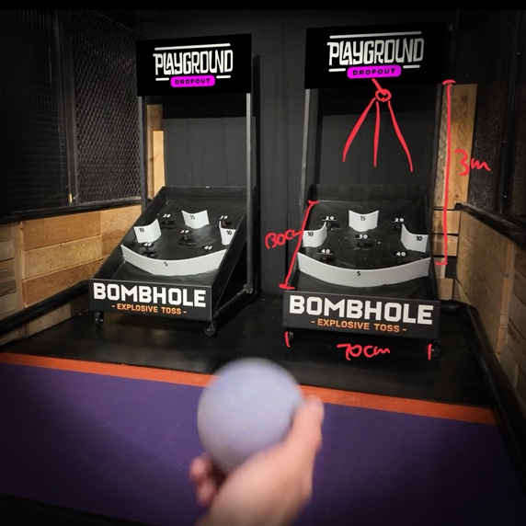

calculation
For vision tracking
typically needs at least 5–10 pixels across the smallest feature.
For reliable tracking of balls, recommend 12–16 pixels
Aim diameter resolution 15px

4k camera not necessary
Want 1080p (1920 × 1080 px) but high frame rate, for low latency, better tracking
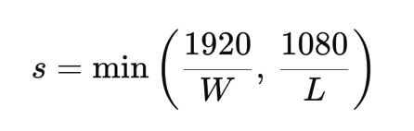
S = min(1920 / 0.7, 1080/1.3) = 830.769 px/m
Scalling board size 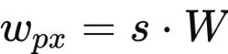
Wpx = 830.769 * 0.7 = 581.54 px
Lpx = 830.769 * 1.3 = 1080px (fills vertically)
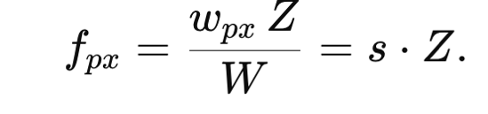
Focal length fpx = 830.769 * 3 = 2492.31px
Pixels correspond to ball: 0.1 * 830.769 = 83.08 px
10cm hole: 83.08px, 12 cm hole: 99.70px

Convert fpx into focal length (mm)
Using usb camera/ smartphone camera
Usb camera: 1/2.3" → ~ 6.3 mm width (common)
Phone camera: 1/2.55" → ~ 5.0 mm width (common)
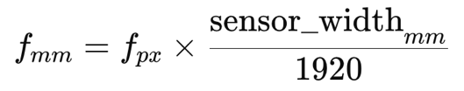
Using usb camera: fmm = 8.17mm
- focal length 8.2mm
Using phone camera sensor: fmm = 6.49 mm
- focal length 6.5mm
summary: 3m height, 1080p camera, if usb 8.2mm focal length
Frame Rate
Assuming 1-3 seconds
30fps is enough, smooth trajectory
Frames per event (1–3 s): 30–180
the ball moves ~0.03 m per frame (if 1 m/s)
~8 pixels per frame (0.03 m × 1920 pixels / 1 m).

SUMMARY
Camera: 1080p (1920×1080), 30–60 FPS, mounted 3.0 m from the board.
- Detect ball presence reliably in frame (per-frame detection).
  - Target: detection precision ≥ 0.98, recall ≥ 0.98 in nominal conditions. (ROI threshold)
- Determine collision (ball hits pedal/board) vs passes by.
  - Target: classification accuracy ≥ 0.98, false collision rate ≤ 1%.
- Robustness: maintain targets across speeds, lighting, multiple balls, minor camera misalignment.
Data collection
Total clips: 300 (2-4 s each)
Normal: 140 clips
Edge case/ Stress: 160 clips (lighting changes, multiple balls, very fast throws, occlusions)
Each clip should include at least 1–2 collisions.
Data Distribution
- Ball speed: slow (0.5–1 m/s) 20%; medium (1–3 m/s) 50%; fast (3–6 m/s) 20%; extremes 10%.
- Trajectories: straight center, diagonal, bounce before pedal.
- Outcomes: collision (50% of clips), pass/no collision (35%), ambiguous (15%).
- Multi-ball: 10% of clips contain 2 simultaneous balls; 5% contain 3 or more.
- Background motion: Assume to be same
- Lighting: Assume to be same
Label each clip
70% training, 10-15% validating, 10-15% testing
I could use cross validation
Collision vs passing through
If the ball stays inside the ROI for at least one frame, consider it a collision.
If immediately leave, passing by
collision if ball center enters ROI and overlaps ROI by >= 50% of its diameter for more consecutive frame

background subtraction, thresholding
feed in simple neural network
prediction base on velocity
next step
find the camera
data collection (how to mount the camera, what computer
what is the experiment,

go pro, mounting device

